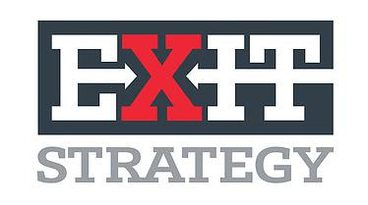
EXIT STRATEGY NORTH – MEETING SPACE

Our Exit Strategy North location offers a multi-functional meeting space that you can rent to debrief after playing a room, hold a meeting or have a bite to eat.

Capacity
Up to 20 people (table and chairs) Up to 30 people (chairs only)

Price list
Table and/or chairs only $100/hour
Wi-Fi access $20/event
Multi-media (projector, screen, sound system) $25/hour
Catering/cleaning fee $25/event

Bundles
You need everything mentioned above? We hear you! The longer you stay, the more you save:
1 hour for all services = 5% off
2 hours for all services = 10% off
3 hours and longer for all services = 15% off
If you are playing one of your rooms during your scheduled meeting space time, you will be charged for that time as well.

Food and alcohol
If you would like to have food catered in, simply make your arrangements with your favorite restaurant/caterer. We have a list of restaurants in the area that offer catering. Let us know if you need it. Please note that we do not have an alcohol license so alcoholic beverages will not be allowed.

EXIT STRATEGY SOUTH – 9539 PINNACLE DR. STE 300 CHARLOTTE NC 28262 – 980-859-4482

